**STRENGTHENING ROUTINE IMMUNIZATION**

**SIMPLE GUIDE FOR REACHING EVERY PUROK**

**FOR HEALTH CENTERS**

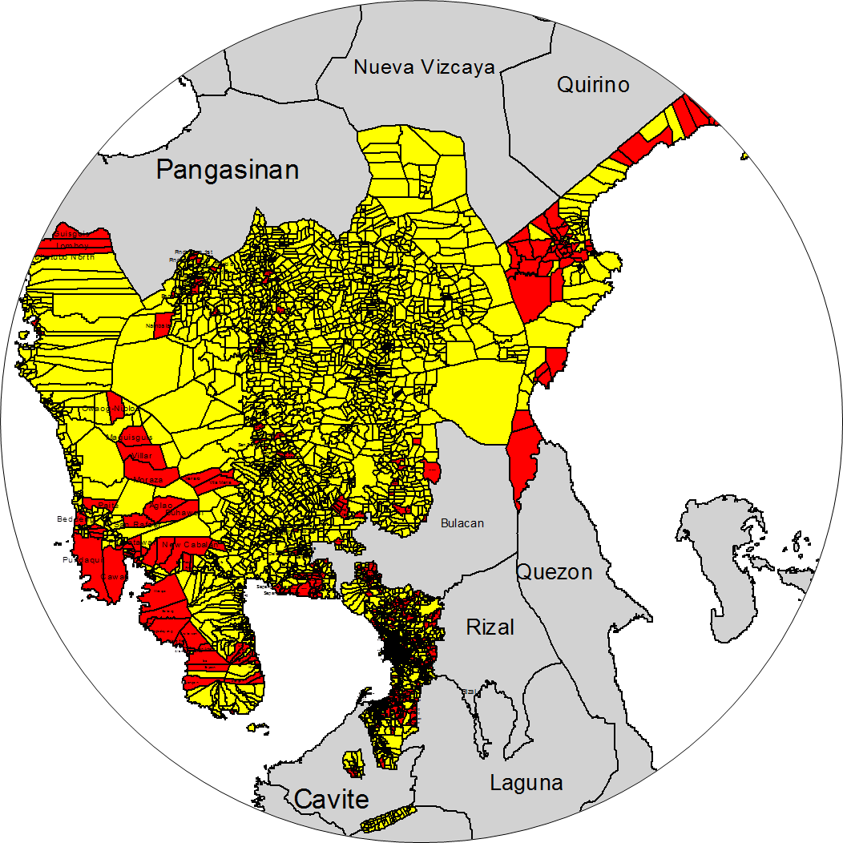 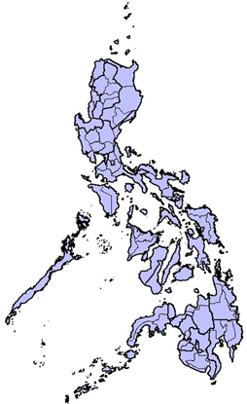

Adjacent Area

High Risk

Low Risk

**Department of Health, Philippines,**

**May 2015**

**PURPOSE OF THIS GUIDE**

This guide is intended for Health Center (HC) or Rural Health Unit (RHU) staff to help them reach every purok, block, sitio in a barangay with routine vaccination.

***Remember:*** *The term “purok” in this document also refers to any sub-division of a barangay such as block, Sitio, street, zone*

The Reaching Every Purok (REP) strategy was first introduced in 2013 as the next step after the Reaching Every Barangay (REB) strategy. The strategy responds to continued significant immunity gaps among disadvantaged puroks, blocks or sitios in a barangay.

The 2014 Measles-Rubella-Polio Mass Immunization (MR OPV MI) campaign provided the first opportunity to identify high risk puroks on a national scale, reach them with the campaign vaccines, and measure their routine vaccination status. The campaign provided a useful basis for continuing access to regular vaccination services in high risk areas.

The guide shows:

* how to use the locally available data to strengthen routine immunization services
* how to prioritize and reach high risk puroks with vaccination activities
* how to continue to monitor progress by purok

**WHAT IS NEW ABOUT THIS GUIDE**

The REP Strategy puts the focus on the barangay at purok/block/sitio level. This guide provides simple steps which can be followed by RHU/HC staff to reduce the immunity gap* in high risk puroks. The strategy includes door-to-door monitoring of vaccination status within the barangay, which is designed to be well suited to densely or highly populated areas, like urban barangays.

**\*An immunity gap occurs when some individuals in a community are not fully protected by vaccination**

**SOME URBAN IMMUNIZATION PROBLEMS WHICH CAN BE ADDRESSED BY THE REP STRATEGY**

1. Uncertain urban population denominators resulting in incomplete TCL/registers
2. Population movement and migration from other regions to urban areas
3. Informal urban settlements not included in official population
4. High cost of transport to the health center for the urban poor
5. Urban population shared across regional borders needing coordinated plans

**CONTENTS OF THIS GUIDE**

# SECTION I. CLOSING IMMUNITY GAP IN HIGH RISK PUROKS

# A. Making a health center work plan for Reaching Every Purok every quarter using Form 1

# B. Making a barangay map showing high risk puroks

## C. Deciding when a follow up vaccination should be done

# D. Making a master list of children with their immunization status in high risk puroks using Form 2

# E. Managing the Target Client List by purok

# F. Listing children for follow up immunization based on Target Client List and master listing using Form 3

# G. Conducting quarterly card check in high risk puroks using Form 4

H. Consolidating and monitoring of quarterly card check using Form 5

# I. Monitoring and supervision of immunization program using Form 6

# J. Monitoring and managing vaccine supplies using Form 7

K. Monitoring progress by purok

**SECTION II. MAINTAINING HIGH POPULATION IMMUNITY IN LOW RISK PUROKS**

# A. Quarterly Rural Health Unit or Health Center immunization coverage monitoring using Form 8

**IMPLEMENTING REACHING EVERY PUROK STRATEGY**

**This algorithm shows the vaccination activities for high and low risk puroks.**

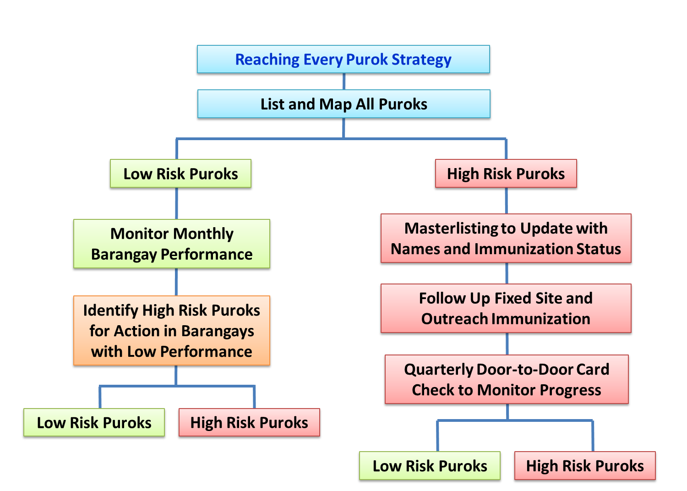

**The regular classification of puroks as high or low risk** is based upon the data collected from quarterly door to door immunization card checks conducted in high risk puroks.

The following three main activities for high risk puroks are described in detail in this guide:

**1. PLANNING:**

* **Master listing** to update the TCL with the names and immunization status of children

**2. TAKING ACTION**

* **Follow up vaccination** using fixed site and/or outreach service delivery

**3. MONITORING**

* **Quarterly door-to-door card check** of children’s immunization status to monitor progress of the purok on moving from high to low risk category

For puroks classified as low risk the following activities are described in this guide:

1. Monthly monitoring of the barangay’s immunization performance
2. Identifying high risk puroks within low performing barangays for corrective action and subsequent classification as high or low risk

# SECTION I. CLOSING IMMUNITY GAP IN HIGH RISK PUROKS

# A. MAKING A HEALTH CENTER WORK PLAN FOR REACHING EVERY PUROK EVERY QUARTER USING FORM 1

Form 1 shall be used to make a simple work plan for an RHU/HC to implement the strategies for Reaching Every Purok. The work plan will schedule the activities needed such as master listing, follow up immunization and card checks.

**HOW TO USE FORM 1 IN PREPARING THE QUARTERLY WORK PLAN**

This is an example of a work plan using Form 1 for the first quarter only. Make a new work plan every quarter using the results of the previous quarter. Page 8 shows Form 1 (Work Plan for four quarters of one year).



*HR= high risk, LR= low risk, ND= not done

1. Make a list of each Barangay in an RHU/ HC catchment area.

2. List every purok within each Barangay.

3. Make a selection of high risk puroks from this list

**Options for Initial High Risk Purok Selection**

Request Health Centres staff to decide which puroks are high risk based on their local knowledge:

* If Purok coverage data is available: Identify puroks known to have <90% MCV1 coverage or puroks where >80% of children do not have immunization cards.
* If Purok coverage data is not available: Use local knowledge about community situation to select high risk purok. Consider criteria such as, but not limited to: congested urban areas, re-settlement areas, remote rural areas or places recently affected by severe disaster.

**Regular Quarterly High Risk Purok Selection**

Use the results of the most recent quarterly door-to-door card check.

4. For puroks classified as high risk:

a. Enter the date master listing will be done in that purok

b. Enter the dates for follow up immunization in that purok

5. Enter the date for the next door-to-door card check (this can be done after a follow up immunization round).

6. Enter the results of the latest door-to-door card check: high risk (HR) or low risk (LR). For the succeeding quarters use the latest quarter card check results and follow #4 for all puroks classified as high risk.

For example, for quarter 2, use the data from the latest quarter 1 card check; Use the data from the latest quarter 2 card checks for quarter 3, and so on.

## HOW TO CLASSIFY PUROKS AS HIGH OR LOW RISK

Review the results of latest door-to-door card check:

* Compute the proportion (%) of children with complete immunization as indicated in the cards using this formula:

Number of children with complete immunization from card check X 100 Total number of children with cards

High Risk Purok**:** <90% of children had complete immunization

* In puroks where a significant number of children do not have cards, compute the proportion (%) of Children with no cards using this formula:

Number of children without cards X 100

Total number of children checked

High Risk Purok: ≥80% of children aged 12 to 23 months are without cards



# B. MAKING A BARANGAY MAP SHOWING HIGH RISK PUROKS

Below is an example of a Barangay Map that can be displayed on the wall of the Barangay Health Station. It shows high risk puroks shaded red. If known, it is also helpful to indicate the number of households per purok. The map can be updated to reflect changes in the risk status of each purok.

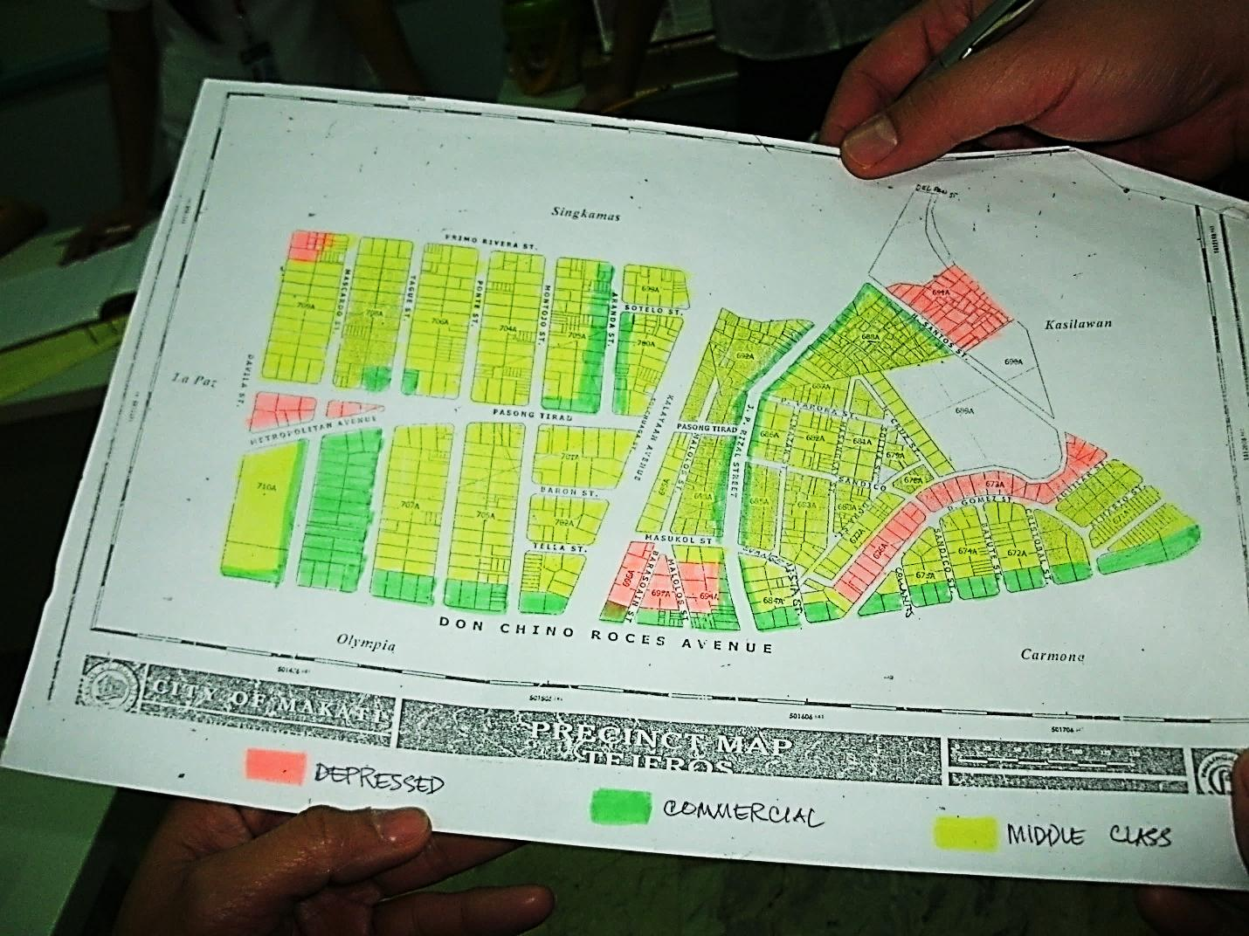

## C. DECIDING WHEN A FOLLOW UP VACCINATION SHOULD BE DONE

A follow up immunization is needed in a high risk purok where card check shows <90% of children are completely immunized.

# D. MAKING A MASTER LIST OF CHILDREN WITH THEIR IMMUNIZATION STATUS IN HIGH RISK PUROKS USING FORM 2

# 

**WHAT IS A MASTER LIST?**

## A master list is a list of names of children including their date of birth or age exact address and the doses of vaccines they have received.

## Ideally, the master list is made by going door-to-door in high risk puroks and asking for the immunization cards of children under 2 years of age and their mothers. It is ideal for a health worker to bring the TCL while doing the master listing to allow validation of child’s immunization in cases of lost immunization card.

The information gathered on the master list is then transferred into the TCL.

This table is an example of Form 2 used for master listing of children under 2 years of age.



**WHEN TO USE A MASTER LIST?**

## A master list is very useful when there are uncertainties about the true number of children in a purok, and when their true immunization status is not known.

* Ideally; make the master list by going door-to-door in high risk puroks and asking for the immunization cards of children under 2 years of age and their mothers.
* In areas with unstable populations (dense urban areas, disaster areas, regular population movement): repeat the update of the master list regularly (quarterly)
* In areas with stable populations: repeat the update of master list as needed (annual update as minimum)

Here are examples of different scenarios where a master listing will be helpful.

**Scenario #1** - a big city with a very mobile population where many children may not have immunization cards and may not be registered in the TCL. In this case, making a master list is a good way to validate and update the TCL.

**Scenario #2** – an area affected by a natural disaster where TCLs and other immunization records have been lost and have to be re-made.

**Scenario #3 –** an area where a follow up immunization is being planned and managers need to know the number of eligible children and quantities of vaccines needed.

***Remember:*** *Making a master list needs training and supervision. The master list should be of good detailed quality, complete and regularly updated as possible*.

## HOW TO USE THE MASTER LIST

**Each master list form is for one purok (see Form 2)**

1. Go from door-to-door in the purok and ask if there is a child aged under 2 years of age in the house.
2. If yes, write the name, date of birth or age of the child, mother’s name and the detailed address. If many children are living in the house, list all children under 2 years of age.

The master list can be initially prepared by adding names and vaccination details of children from that purok who are already in the TCL. However, going from door-to-door is still recommended to include children who are not yet in the TCL or to determine children who permanently left the purok to live in another place.

1. Ask the mother to show the immunization card of each child.

**a. If an immunization card is available:** Place a check mark (√) on the form against each vaccine that has been given from the record on the immunization card.

**b. If no immunization card available:**

**If the mother can remember well**, place a check mark (√) against each vaccine on the form and indicate “recall” under the column for remarks. This shall prompt the health worker to check validity of mother’s recall against the TCL. Then, provide a new card, place a check mark (√) on the card against vaccines already given (dates will not be known).

Try to find the name of the child in the TCL to validate the mother’s recall and add on the new card the dates that the vaccines were given. Update vaccination data in Form 2 as needed after reviewing the TCL.

**If the mother cannot remember**, try to find the name of the child in the TCL. If the name and vaccines given are in the TCL, provide a new card with the dates the vaccines received.

If child’s name cannot be found in the TCL, provide a card to be used for follow up vaccinations and enter the name in the TCL. Update vaccination data in Form 2 as needed after reviewing the TCL.

***Remember:*** *Write the exact address in the master list, so the child can be easily located again for follow up.*

## HOW TO USE THE DATA ON THE MASTER LIST

1. Transfer and update the names, ADDRESSES and immunization status to the TCL. This is easier when one section of the TCL is dedicated to each purok or if possible, one TCL per purok.
2. When doing the door-to-door check, advise mothers where and when they should go to get their children fully vaccinated.
3. Plan a follow up immunization activity for the purok: use a variety of strategies:

* Mobilization of mothers and children by volunteers to come to a health center or barangay health station (BHS)
* Set up temporary purok outreach immunization post conveniently located
* Door-to-door vaccination, if feasible

# E. MANAGING THE TARGET CLIENT LIST (TCL) BY PUROK

The challenge for management of the TCL is the ability to find each child without difficulty when doing follow up work.

**TCL Management Option 1 (recommended):**

In urban areas where purok/block/sitio has very large populations, dedicate a separate TCL to each area (*see picture below*). Begin a new year with a new TCL by registering the new year’s birth cohort by purok, month by month. Children born in the previous year can be followed up in that previous year’s TCL.

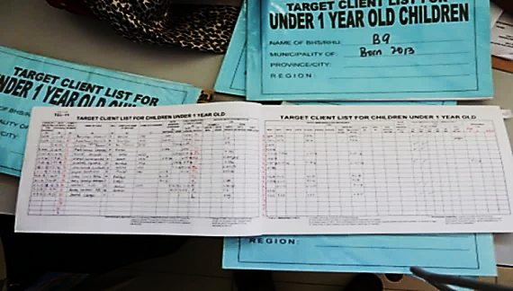

*This photo shows an example of TCLs prepared by purok (block) being used in one health center in the City of Manila. These TCLs are grouped and filed per barangay. If the new TCL for children under-five is available, data recording should ideally be maintained by purok/sitio/block.*

**TCL Management Option 2:**

Sub-divide and mark the pages of one TCL so that each purok, block or sitio will have dedicated separate pages. The separate pages can also be divided by month of birth.

Make sure to provide sufficient pages to enter all of the eligible children for each purok/sitio/block based on the master list and add few more pages to include the estimated number of future babies that maybe born in or transfer to the purok within the year.

**TCL Management Option 3 (least preferred):**

Use one TCL per RHU/ HC but ensure that the column for address in the TCL will be completely filled out (which should include purok/block/sitio/ street and even landmark near the house of infant) to ensure easy tracking of target children.

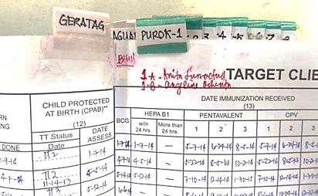

*This is an example of a TCL with pages divided per barangay and per purok used in one health center in Region III. Color-coded tags are used to mark records per barangay and per purok. Yellow tags mark the beginning of the recording for a barangay followed by green tags to separate the records per purok within the same barangay. This was prepared after master listing per purok has been completed.*

## OPTIONS IN URBAN AREAS WHERE THE POPULATION IS VERY MOBILE AND TCL IS INCOMPLETE

1. The midwife can keep the master list and update it periodically by returning to the same purok and updating the form with vaccination data from the same children.

2. Consider whether it is possible to do outreach vaccination at the same time as master listing.

**WHAT TO DO FOR ZERO DOSE CHILDREN**

## Some children under 2 years of age may have no immunization records because they are lost or damaged by flood/fire etc.

**If there is no recall and no record of vaccination:**

1. Make a new vaccination card
2. Enter the name and address in the TCL
3. Determine which vaccines to give to the child:

**For children UNDER 12 MONTHS:**

It is preferable to give the whole immunization series of vaccine doses, according to age: BCG (1 dose), Penta (3 doses), PCV (3 doses), OPV (3 doses), IPV (1 dose), and MCV (1 dose).

**For children 12 TO 23 MONTHS:**

Since the child at this age is likely to be partially immunized give only OPV (1 dose), Penta (1 dose), PCV (1 dose) and MCV (ideally 2 doses).

***Remember:*** *In some smaller puroks: If a TCL for the purok is available, it is useful to take the TCL to the purok and update it on the spot.*

# F. LISTING CHILDREN FOR FOLLOW UP IMMUNIZATION BASED ON TCL AND MASTER LISTING USING FORM 3

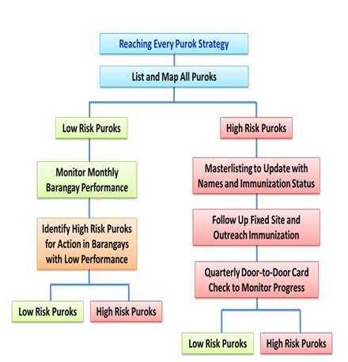

Form 3A and Form 3B are used for listing children and women requiring follow up vaccination based on the TCL and master list. These can be used for all puroks regardless of their risk status.

Use the TCL and other lists, including master lists, to write the names of children and women who are due for their next scheduled dose.

The table below is an example of Form 3A used to list children requiring follow up immunization. Put names of children who need to be followed up to complete all doses.



The next table is Form 3B used to list women who had <3 doses of tetanus toxoid (TT) to follow up for the next TT dose.



# G. CONDUCTING QUARTERLY CARD CHECK IN HIGH RISK PUROKS USING FORM 4



# Using form 4, the quarterly card check measures the risk status in one purok with door-to-door visits for children aged 12 to 23 months.

The quarterly card check is a means of monitoring progress in high risk puroks. It does not need to be as detailed as the master list, because its purpose it to monitor high or low risk status of a purok. It is easier to use from door-to-door because the target is children aged 12 to 23 months who should all be completely immunized already.

Try to check a minimum of 20 houses with eligible children aged 12 to 23 months in each high risk purok every quarter. If the purok has less than 20 houses, check every house.

**Form 4 is used for card checks.**



## HOW TO DO DOOR-TO-DOOR CARD CHECKS

1. Every quarter visit every high risk purok and go door-to-door to check children’s immunization cards.
2. Ask if there are any children aged 12 to 23 months (between 1 and two years).
3. If yes, write the number of children aged 12 to 23 months in that door.
4. Ask the mother to show you the immunization card of each child.
5. Write the number of children with card for that door.

**If there are immunization cards:** Check the card for immunization status and write the number of children in each category:

1. **Completely Immunized** = child received 3 doses of Penta plus MCV1 and MCV2
2. **Partially Immunized** = child missed any one dose of Penta or dose of MCV
3. **Zero dose** = card is available but no doses marked on card. Write the name of the child on the back of Form 4 for later checking/ validation in TCL.

**If there is no card or no other record of vaccination**: Write the number of children under the “no card” category and write the names of children on the back of Form 4 for later checking/ validation in the TCL.

## HOW TO USE THE QUARTERLY CARD CHECK DATA

* Quarterly card check data will be used to decide whether the purok:
* is still high risk and needs a follow up immunization,
* needs updating of the master listing, or
* if immunization coverage has improved that purok becomes low risk
* Enter the findings from Form 4 into Form 5 for consolidation.

# H. CONSOLIDATING & MONITORING OF QUARTERLY CARD CHECK USING FORM 5

# 

# Results of card check are consolidated and monitored every quarter using Form 5.

# 

# This is important to assess how the REP implementation in high risk areas is contributing to the over-all improvement of the population immunity of the barangay. This also allows health worker to monitor puroks for their high risk and low risk status.

## METHOD FOR CONSOLIDATING QUARTERLY CARD CHECK DATA

Enter the total results of the quarterly card check for each purok from Form 4 into Form 5 (sample on Page 20).

***Remember:*** *Card check measures risk status. There is no need to calculate coverage per purok. Coverage should be measured by barangay.*

## SUPERVISOR DECISION ON RISK STATUS

## The supervisor should review the quarterly results on Form 5 and make decisions using the following information.

## Results of card check:

High Risk Purok: <90% completely immunized or >80% has no card

* Date of follow up immunization conducted in high risk purok (if needed)
* Number of doses of Pentavalent and MCV vaccines given during follow up immunization if needed and done

## Based on the above information, the supervisor will decide (1) whether to classify a purok as high risk or low risk and (2) where and when follow up immunization is needed.

* **If a purok is still high risk:** determine if a follow up immunization activity needed
* **If follow up immunization done:** enter the date that the follow up immunization was conducted
* **When the follow up immunization has been completed:** enter the results showing the total number of doses of Pentavalent and MCV given

## Information from Form 5 can also be used to monitor indicators (see Page 23) of progress using REP strategy.

***Remember:*** *It may not be possible to change a purok status from high risk to low risk status based upon only on one or two month’s data. It is more reliable to follow progress for 12 months*before changing their status.



# I. MONITORING AND SUPERVISION OF IMMUNIZATION PROGRAM USING FORM 6

Immunization program supervisors at the RHU/HC will conduct quarterly monitoring using Form 6 (see sample on the next page).

This checklist can also be used by EPI managers at the regional, provincial or city level.

|  |  |  |  |  |
| --- | --- | --- | --- | --- |
| **FORM 6: QUARTERLY SUPERVISORY CHECKLIST**  **Name of Health Center: ________________________**  **Name of Supervisor: ___________________________ Date: _________________** | | | | |
| **COMPONENT** | **WHAT TO CHECK** | **WHAT TO LOOK FOR** | **ENTER**  **Y/N** | **COMMENT** |
| **SERVICE DELIVERY** | Check TCL | * TCL updated and complete |  |  |
| * TCL showing unimmunized gaps |  |  |
| * Lists of names for follow up doses |  |  |
| Map | * Health Center maps showing barangays |  |  |
| Lists of population | * Barangays listed with population of each |  |  |
| * Names of puroks listed |  |  |
| * High Risk Puroks identified |  |  |
| Session Plan | * Outreach sessions planned and monitored |  |  |
| **MONITORING** | Monitoring Chart | * Chart up to date |  |  |
| * Magnitude of drop outs displayed |  |  |
| Card Checking in HR puroks | * Quarterly card checking planned and monitored |  |  |
| * Results of card check documented |  |  |
| Low performing Barangays | * Coverage by Barangay recorded * Low performers investigated by review of TCL |  |  |
|  |  |  |
| **SURVEILLANCE** | Reports of suspected VPDs | * Suspected cases reported and investigated on time |  |  |
| Case Investigation | * Case investigation forms available in health center |  |  |
| **COLD CHAIN, LOGISTICS AND SUPPLY** | Check Refrigerator | * Refrigerators functioning; if not has report been made and follow up |  |  |
| Temperature monitoring | * Temperature record twice per day |  |  |
| Check vaccine supply | * Vaccine log book in use |  |  |
| * Any stock out/over stock |  |  |
| **AEFI** | Immunization Safety | * Any prefilling or re-capping of syringes |  |  |
| **COMMUNICATION** | Poster with national schedule | * Immunization Schedule Poster displayed |  |  |
| Mothers knowledge | * Mothers correctly informed about next dose/visit |  |  |
| Names and phone numbers of BHWs | * Directory of BHWs names and phone numbers |  |  |
| Session plan displayed | * Fixed and outreach sessions schedule displayed for public |  |  |
| **PLANNING AND SUPERVISION** | Microplan available | * Microplan shows activities for high risk puroks |  |  |
| Supervisory plan | * Schedule of supervisory visits |  |  |
| Supervisory log book | * Action taken from previous visits |  |  |

# J. MONITORING AND MANAGING VACCINE SUPPLIES USING FORM 7

Form 7 is used for monitoring vaccine supply by comparing the number indicated in the Vaccine Stocks Records to physical count.

Responsible officer should complete the table (see sample on the Page 24) for each item listed.

# K. MONITORING PROGRESS BY PUROK



Ideally, a database maybe developed to monitor high risk purok progress at the provincial or city level. An example of a database developed during the MR-OPV mass immunization campaign in September 2014 in Region III which can still be used for implementing REP is shown on Page 25.

One can seek support from regional, provincial or city IT personnel for the development of a simple (Microsoft Excel-based) database for this purpose. Having an electronic database facilitates easier data analysis and tracking of progress.

Once available, transfer the data from Form 5 (Consolidated monitoring of quarterly card checking in high risk puroks) into the database.

**PUROK INDICATORS TO MONITOR**

1. High Risk Purok:<90% of children with cards have complete immunization OR >80% have no card

2. Low Risk Purok: >90% of children with cards have complete immunization

3. Purok needing follow up immunization: based on the information on the (1) date last follow up immunization was done and (2) total number of pentavalent and/or measles vaccines given.



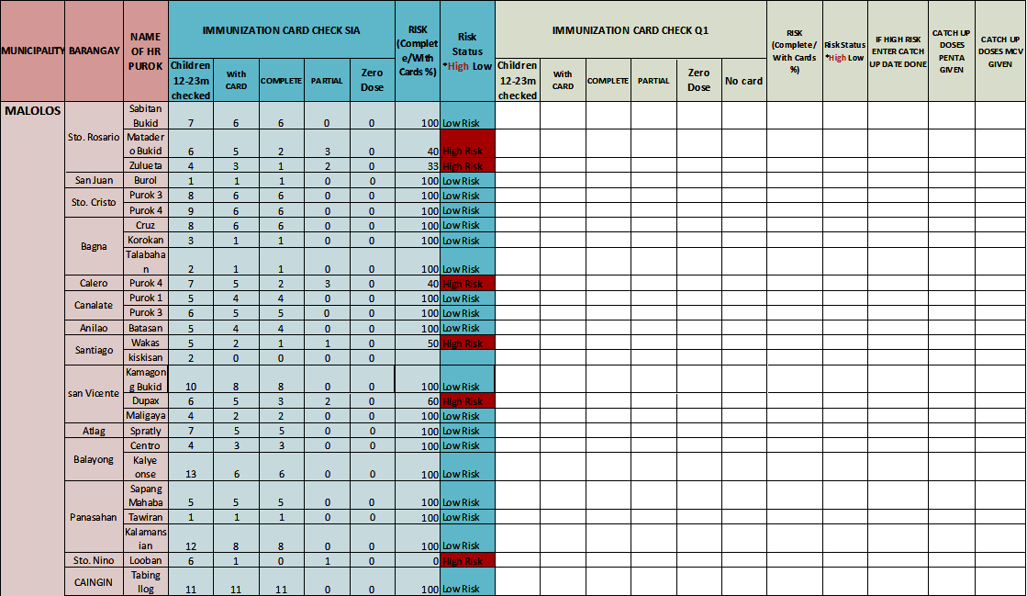

# SECTION II. MAINTAINING HIGH POPULATION IMMUNITY IN LOW RISK PUROKS

# A. QUARTERLY RHU/ HC IMMUNIZATION COVERAGE MONITORING USING FORM 8

High population immunity can be maintained in low risk puroks by regular analysis of reported coverage data by barangay. Low risk puroks may become high risk during the course of the year for many reasons, so it is essential to review data on a regular basis.

Quarterly data analysis at the RHU/HC will identify low coverage barangays (with or without high risk puroks) where additional actions are needed, such as conducting outreach immunization activities.

A sample of Form 8 on page 27 shows how to monitor coverage data per barangay, which will help supervisors/EPI coordinators in planning for appropriate actions.

If the Barangay coverage data shows low performance, supervisors should review the TCLs per purok for the low performing barangay and try to decide which puroks have high number of unvaccinated/incompletely vaccinated children, irregular sessions or any other problems. In this way a previously low risk purok may achieve a high risk status, which will call for master listing and follow up immunization activities.

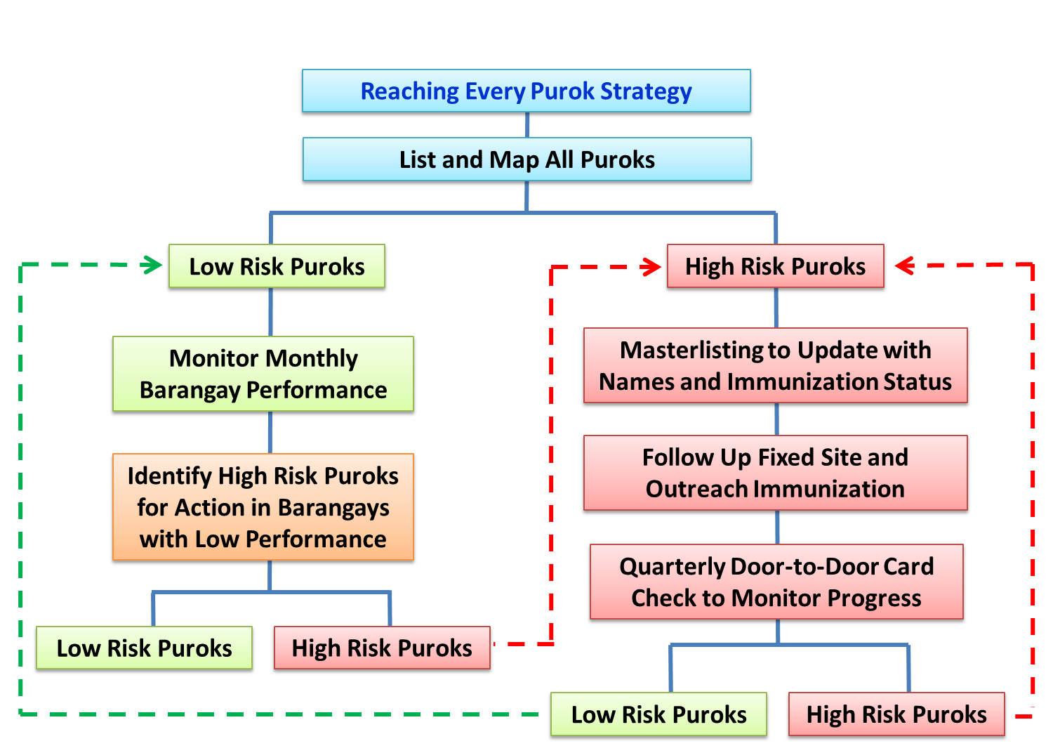

**The REP Cycle: from high risk purok to low risk purok.**



**NOTES:**

_____________________________________________________________________________________________________________________________________________________________________________________________________________________________________________________________________________________________________________________________________________________________________________________________________________________________________________________________________________________________________________________________________________________________________________________________________________________________________________________________________________________________________________________________________________________________________________________________________________________________________________________________________________________________________________________________________________________________________________________________________________________________________________________________________________________________________________________________________________________________________________________________________________________________________________________________________________________________________________________________________________________________________________________________________________________________________________________________________________________________________________________________________________________________________________________________________________________________________________________________________________________________________________________________________________________________________________________________